**Components**

**TOTAL POINTS 4**

1.Question 1

What characteristics distinguish a Solid State Drive from a Hard Disk Drive? Check all that apply.

**1 / 1 point**



Smaller form factor

**Correct**

Right on! SSDs have non-moving parts, are a smaller form factor, and also utilize non-volatile memory.



Non-moving parts

**Correct**

Right on! SSDs have non-moving parts, are a smaller form factor, and also utilize non-volatile memory.



Uses Disk Platters



High RPMs

2.Question 2

True or false: If you plug in a 220v appliance into a 120v outlet, the appliance could get damaged.

**1 / 1 point**



TRUE



FALSE

Ans True

**Correct**

You got it! While plugging a 220v appliance into a 120v outlet won't cause immediate harm to your appliance, it could still cause appliance deterioration.

3.Question 3

How long will it take to transfer a file size of 1GB on a USB 2.0 and a USB 3.0 drive?

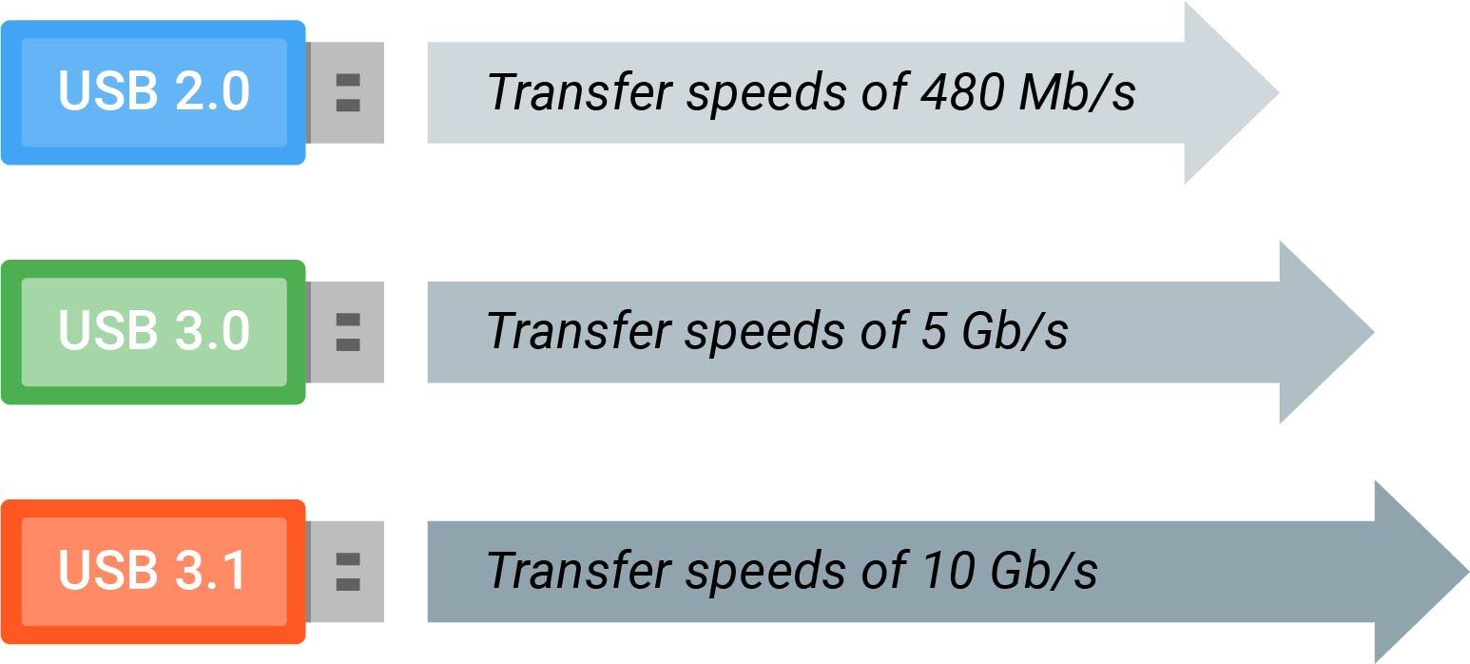

**1 / 1 point**



~20 seconds on a USB 2.0 drive; ~2 seconds on a USB 3.0 drive



~ 17 seconds on a USB 2.0 drive; ~2 seconds on a USB 3.0 drive



~17 seconds on a USB 2.0 drive; ~.02 seconds on a USB 3.0 drive



~ 20 seconds on a USB 2.0 drive; ~.02 seconds on a USB 3.0 drive

Ans 2

**Correct**

Great job! Theoretically, USB 2.0 has a bandwidth of 480 Mb/s, which is roughly 60 MB/s. It would take around 17 seconds to transfer 1024 MB of data.

4.Question 4

Which of these is used to charge devices? Check all that apply.

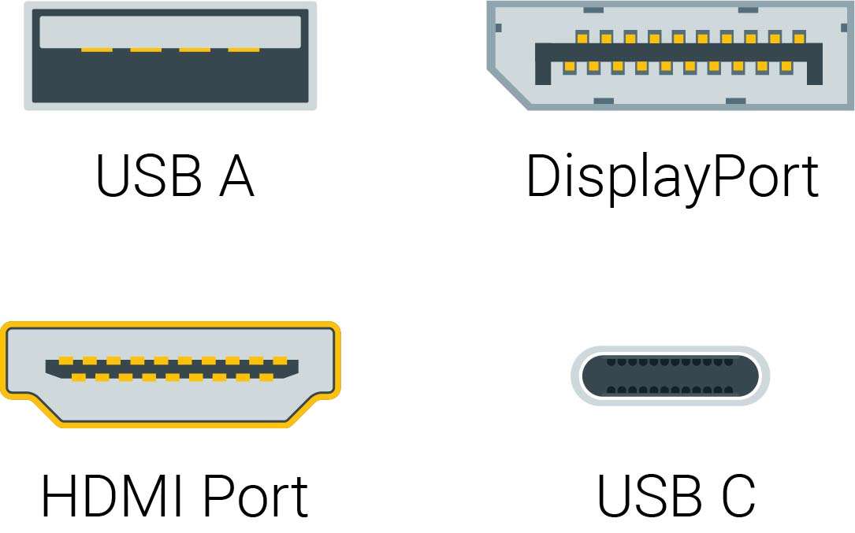

**1 / 1 point**



Picture of USB A.

**Correct**

Well done, you! These are types of USB ports.



Picture of DisplayPort.



Picture of HDMI Port.



Picture of USB C.

**Correct**

Well done, you! These are types of USB ports.